**EE345L – Lab 5: Music Player and Audio Amp**

Ty Winkler and Jeremiah Bartlett

03/7/16

1. **OBJECTIVE**

The objective of this lab is to design and build a music player using a TLV5616 DAC and TPA731D audio amp. In this lab we will learn how to communicate with the DAC using SSI, how to store music in the TM4C123’s memory, and how to assemble a circuit requiring a DAC and audio amp.

1. **ANALYSIS AND DISCUSSION**
   1. **DAC Errors**

DACs have three different errors an offset error which is the offset of actual output compared to ideal, a gain error which is the difference between ideal and actual output when a full spectrum of output is sent to the DAC, and a differential nonlinearity which is the offset of the output when a linear set of values is output from the DAC.

* 1. **SSI Interfacing**

The timing requirements for the DAC are as follows: setup time 8ns, hold time 5ns, and pulse duration 25ns. The SSI frequency is 8MHz = 125ns. Thus the data available is set to 125ns and the data required is 38ns making the data available longer than the time needed to input data to the DAC.

* 1. **Spectrum Analyzer**

The spectrum analyzer takes the largest and lowest values of the input frequency and by adding an offset a frequency range is determined.

* 1. **TPA731**

The TPA731 audio amp amplifies low power audio signals bring the frequencies to a suitable level for driving a speaker. If we were to use the speaker directly with the DAC, the sound coming from the speaker would not be as clear and at a much quitter volume.

1. **Software & Hardware Design Solutions**
   1. **Hardware Design**

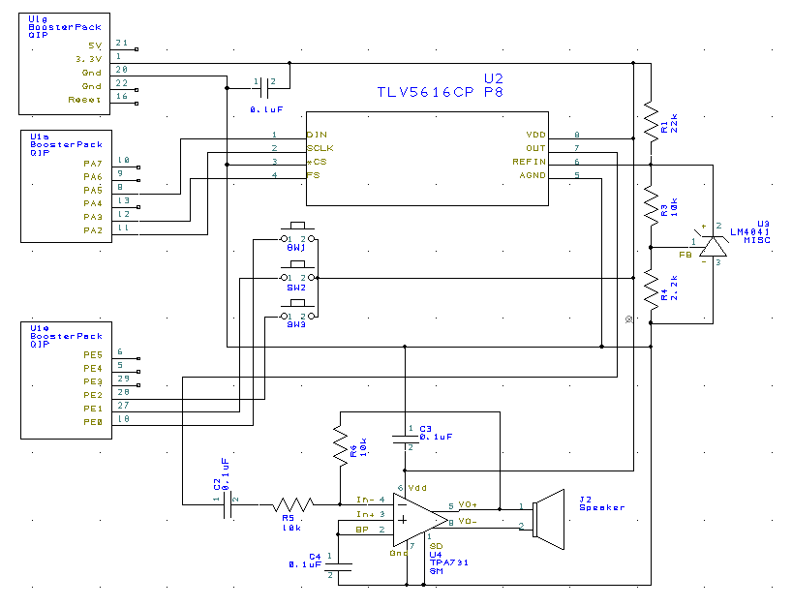

* 1. **Measurement Data**

Resolution, Range, Precision, and Accuracy

|  |  |  |
| --- | --- | --- |
| DAC_Out(X) | Expected V Out | Actual V Out |
| 0 | 0 | 0 |
| 512 | 0.4125 | 0.3 |
| 1024 | 0.825 | 0.6 |
| 1536 | 1.2375 | 1.3 |
| 2048 | 1.65 | 1.8 |
| 2560 | 2.0625 | 1.9 |
| 3072 | 2.475 | 2 |
| 3584 | 2.8875 | 2.6 |
| 4096 | 3.3 | 3 |

Resolution =

Range = 3

Precision = .3

Accuracy = .3

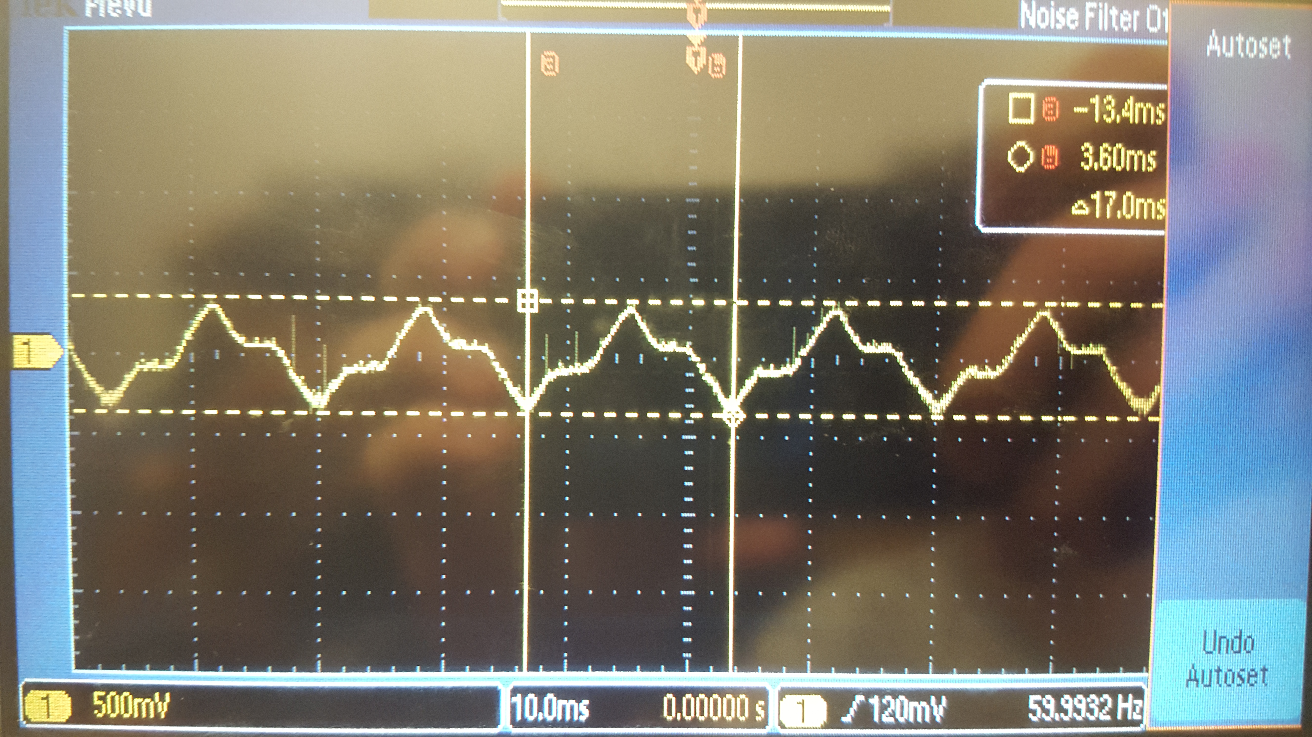

Experimental Response of the DAC & SNR

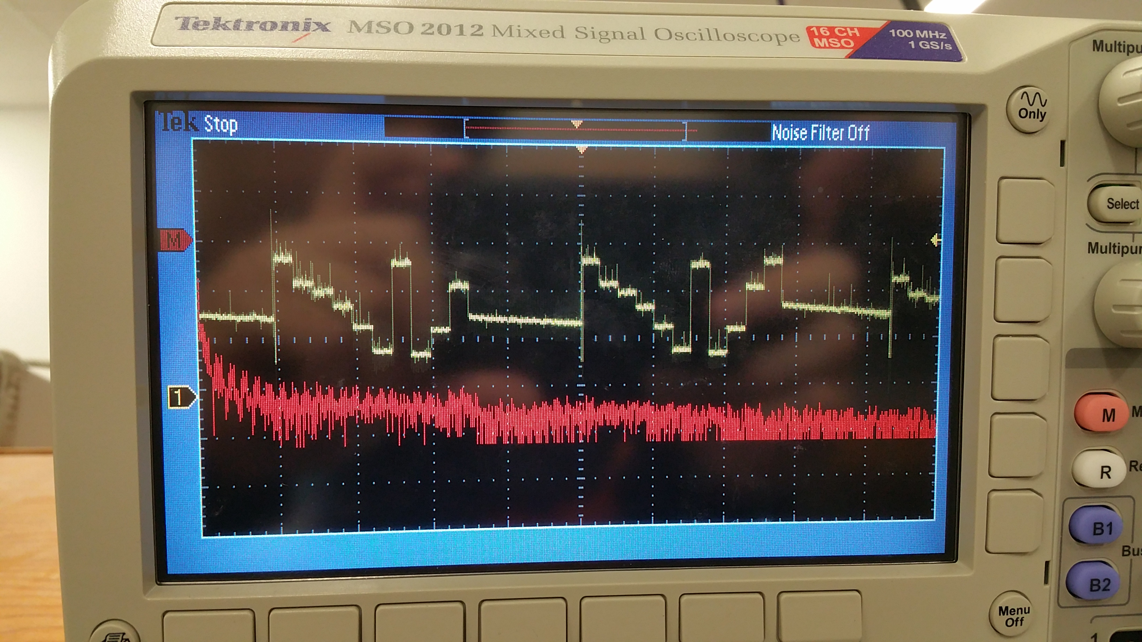

SNR = 20dB

Debugging Data Dump of 100 interrupt times

0x20000034 A2 00 00 00 A2 00 00 00 - A2 00 00 00 A2 00 00 00 ................

0x20000044 A2 00 00 00 A2 00 00 00 - A2 00 00 00 A2 00 00 00 ................

0x20000054 A2 00 00 00 A2 00 00 00 - A2 00 00 00 A2 00 00 00 ................

0x20000064 A2 00 00 00 A2 00 00 00 - A2 00 00 00 A2 00 00 00 ................

0x20000074 A2 00 00 00 A2 00 00 00 - A2 00 00 00 A2 00 00 00 ................

0x20000084 A2 00 00 00 A2 00 00 00 - A2 00 00 00 A2 00 00 00 ................

0x20000094 A2 00 00 00 A2 00 00 00 - A2 00 00 00 A2 00 00 00 ................

0x200000A4 A2 00 00 00 A2 00 00 00 - A2 00 00 00 A2 00 00 00 ................

0x200000B4 9E 00 00 00 A2 00 00 00 - A2 00 00 00 A2 00 00 00 ................

0x200000C4 A2 00 00 00 A2 00 00 00 - A2 00 00 00 A2 00 00 00 ................

0x200000D4 A2 00 00 00 A2 00 00 00 - A2 00 00 00 A2 00 00 00 ................

0x200000E4 A2 00 00 00 A2 00 00 00 - A2 00 00 00 A2 00 00 00 ................

0x200000F4 A2 00 00 00 A2 00 00 00 - A2 00 00 00 A2 00 00 00 ................

0x20000104 A2 00 00 00 A2 00 00 00 - A2 00 00 00 A2 00 00 00 ................

0x20000114 A2 00 00 00 A2 00 00 00 - A2 00 00 00 A2 00 00 00 ................

0x20000124 A2 00 00 00 A2 00 00 00 - A2 00 00 00 A2 00 00 00 ................

0x20000134 A2 00 00 00 9E 00 00 00 - A2 00 00 00 A2 00 00 00 ................

0x20000144 A2 00 00 00 A2 00 00 00 - A2 00 00 00 A2 00 00 00 ................

0x20000154 A2 00 00 00 A2 00 00 00 - A2 00 00 00 A2 00 00 00 ................

0x20000164 A2 00 00 00 A2 00 00 00 - A2 00 00 00 A2 00 00 00 ................

0x20000174 A2 00 00 00 A2 00 00 00 - A2 00 00 00 A2 00 00 00 ................

0x20000184 A2 00 00 00 A2 00 00 00 - A2 00 00 00 A2 00 00 00 ................

0x20000194 A2 00 00 00 A2 00 00 00 - A2 00 00 00 A2 00 00 00 ................

0x200001A4 A2 00 00 00 A2 00 00 00 - A2 00 00 00 A2 00 00 00 ................

0x200001B4 A2 00 00 00 A2 00 00 00 - 9E 00 00 00 AE .............

The interrupt requires 162ns to complete

Current Required w/ and w/o music playing

